Chimera Games Engine Tutorials Tazi Mehdi

Tutorial 1: Installing and Using Chimera

Welcome to Chimera 2D Games Engine! You are about to learn how to download and install the latest version of Chimera Games Engine, which gives you a chance to make your own games on Windows and Xbox 360 In Utilizing Library XNA.

- Installing

Follow these instructions to install the enivrement development.
1 - Begin For Download and install Visual C # 2005, a free version is available here: Download and Subscription you (very easy: on the menu click '? "And bitter register on the product)
Link : www.microsoft.com/express/2005/download/default.aspx

2 - Do the same with Visual Studio 2005 Express Editions Service Pack 1 Available here: Download

File : VS80sp1-KB926749-X86-INTL

Link : www.microsoft.com/downloads/details.aspx?FamilyId=7B0B0339-613A-46E6-AB4D-080D4D4A8C4E&displaylang=en

3 - Thereafter install XNA Game Studio 2.0 is available here: Download

Link : www.microsoft.com/downloads/details.aspx?FamilyId=DF80D533-BA87-40B4-ABE2-1EF12EA506B7&displaylang=en

4-Finaly download Chimera Games Engine Library : Download
Link : http://chimera2d.com/content/view/6/29/

- Using
NO MORE EASY!! ,
Extracted file Chimera Games Engine Library of your choice (Windows) (XBOX360 Or Release Or Debug) in a kit (eg C: \ Programs Files \ Chimera 2D Library)
Thereafter run Visual C # 2.0 STUDIO 2005/XNA GAME create a new project of your choice (Window, XBOX360)

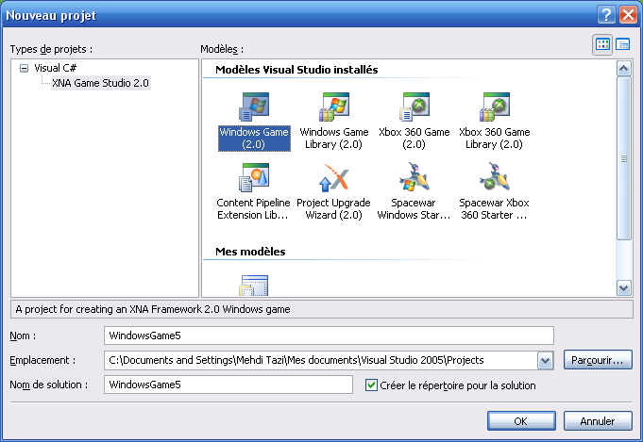

Right Click on Reference and select Add a reference
Click on Browse and go to the folder where you extracted Chimera and select Chimera.dll
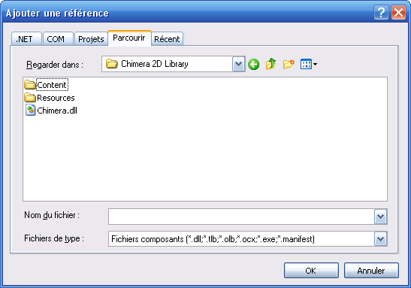

And voila your Project Chimera created. It's too simple no?

If you counted using particle precompiled effects you must copie
The Folder "Resources" in the file "BIN" Your application has generated.
If you have to use the GUI MANAGER done the same with the file manipulation Content..
Both files are present in the file you extract

